

**Capstone Project Report**

**Report 1 – Project Introduction**

– Hanoi, January 2023 –

Table of Contents

I. Record of Changes 2

II. Project Introduction 3

2.1. Overview 3

2.1.1. Project Information 3

2.1.2. Project Team 3

2.2. Product Background 3

2.3. Existing Systems 4

2.3.1.a. My Parking 4

2.3.1.b IParking 5

2.4. Business Opportunity 5

2.5. Software Product Vision 5

2.6. Project Scope & Limitations 5

2.6.1 Major Features 5

2.6.2 Limitations & Exclusions 7

# I. Record of Changes

|  |  |  |  |
| --- | --- | --- | --- |
| Date | A* M, D | In charge | Change Description |
| 10/01/2023 | A |  | Change the name topic to Parking EveryWhere. |
| 12/01/2023 | M |  | Change the name topic to Parking EveryWhere. |
| 15/01/2023 | A |  | Start to build database. |
| 20/01/2023 | A |  | Fix database. |
| 21/01/2023 | A |  | Start to draw Screen flow on figma. |
| 25/01/2023 | M |  | Build Database. |
| 25/01/2023 | A |  | Fix screen flow on figma. |

*A - Added M - Modified D - Deleted

*Table 1: Record of Changes*

# II. Project Introduction

## 2.1. Overview

### 2.1.1. Project Information

* Project name: **Parking EveryWhere**
* Project code: PEW
* Group name: SWP49-G11
* Software type: Software Type: Web

### 

### 2.1.2. Project Team

2.1.2.1. Supervisor

|  |  |  |  |
| --- | --- | --- | --- |
| **Full Name** | **Role** | **Email** | **Mobile** |
| Bui Thi Loan | Lecturer | [LoanBT7@fe.edu.vn](mailto:LoanBT7@fe.edu.vn) | 0942165688 |

*Table 2.1.2.1: Supervisor*

2.1.2.2. Team Members

|  |  |  |  |
| --- | --- | --- | --- |
| **Full Name** | **Role** | **Email** | **Mobile** |
| Pham Minh Tuan | Leader | Tuanpmhe141082@fpt.edu.vn | 0971437756 |
| Phung Nam Duy | Member | Duypnhe141250@fpt.edu.vn | 0981949455 |
| Dao Tuan Phong | Member | Phongdthe140091@fpt.edu.vn | 0963199204 |
| Nguyen Van Phuc | Member | Phucnvhe140098@fpt.edu.vn |  |
| Mai Van Du | Member | Dumvhe140747@fpt.edu.vn | 0976072033 |

*Table 2.1.2.2: Team members*

## 2.2. Product Background

With the rapidly increasing population in Hanoi, the shortage of parking spaces is becoming increasingly severe, resulting in higher parking fees. Currently, there are over 5.9 million vehicles on the roads, with 600,000 of them being cars, and the number is expected to continue to rise in the future. Through the survey, we found that The shortage of parking spaces is a problem that remains unresolved. We want to provide an easier way to find parking spaces for people in Ha Noi. The highlight of our software is help people easier in find a parking space based on people's needs such as distance, price and suitable for all weather conditions.

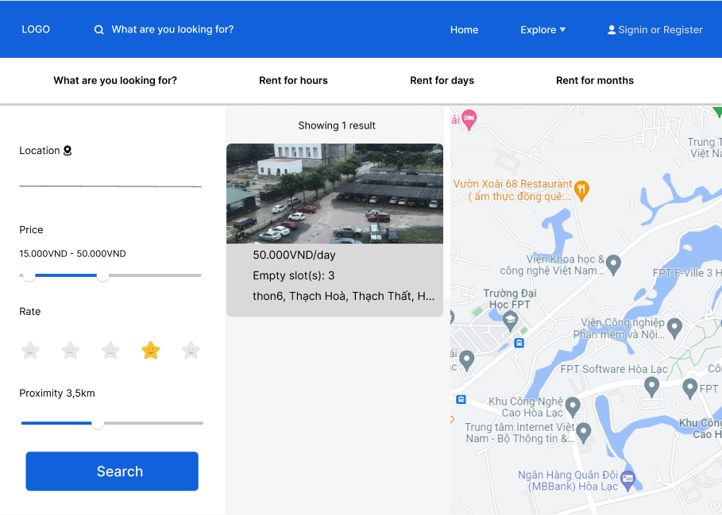

*Figure 2: Home page of Parking EveryWhere system.*

By looking at the Home Page, user will be able to find the desired parking space, can easily adjust the distance, price and the best rated parking space according to their needs.

## 2.3. Existing Systems

### 2.3.1.a. My Parking



*Figure 2.3.1.a: My Parking*

Currently, in the Vietnamese market, there are the My Parking app from Viettel Business Solutions Corporation and Iparking, but users have rated the app as not being good such as parking based on their business land so that people have to go to the right place to have parking, not give vehicle owner a variety of choices.

### 2.3.1.b IParking



*Figure 2.3.1.b: IParking*

This application has not made it clear about the payment when people comes there there are some security takes money but not paid by application as instructed and in the My Parking app, people forced to use Momo wallet or Viettel Pay to pay.

## 2.4. Business Opportunity

Nowadays in Hanoi, the number of vehicles is increasing, and the lack of parking space or parking space has not yet met the needs of the people such as being too far away, too located or not being able to avoid rain and floods.

My team made a website to find a better, more suitable and easily to search parking location to help the people of Hanoi.

The product we make will display the correct information about the parking lot, with more information about the small parking lots to overcome the above disadvantages.

## 2.5. Software Product Vision

We provide functions that display nearby parking lots that are close, within the budget of the person searching, and provide directions through Google Maps to the parking lot. On the other hand, parking lot landlords can upload their parking space on map to have more customers, increasing their business profits.

## 2.6. Project Scope & Limitations

### 2.6.1 Major Features

Below is the Major feature for the PEW System.

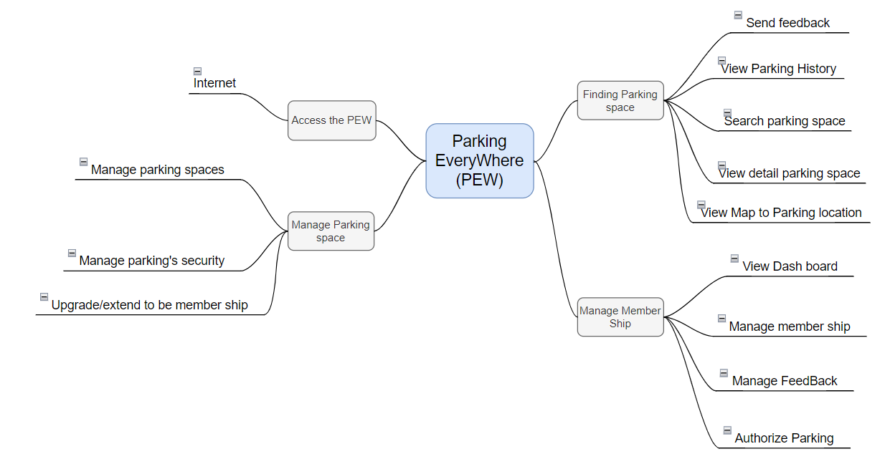

*Figure 2.6.1: Major Features*

The following table show descriptions of main features of our project:

|  |  |  |
| --- | --- | --- |
| **ID** | **Feature** | **Description** |
| FE-01 | Manage parking spaces | Allow parking owner and security can add, update, delete parking spaces. |
| FE-02 | Manage parking's security | Allow parking owner can add, ban, delete security. |
| FE-03 | Upgrade/extend to be member ship | Allow parking owner can upgrade or extend to be membership by buy membership package. |
| FE-04 | Send feedback | Allow vehicle owner can write a feedback after parked. |
| FE-05 | View Parking History | Allow vehicle owner can view history of parking lots. |
| FE-06 | Search parking space | Help vehicle owner to search parking space by name, price, and proximity. |
| FE-07 | View detail parking space | Allow vehicle owner to view name, description, price, time frame, number of empty slots of a parking space. |
| FE-08 | View Map to Parking location | Direct shortest path for vehicle owner to get to chosen parking location. |
| FE-09 | View Dash board | Allow admin to view bar graph showing numbers of register membership in monthly, the column chart shows the total of revenue. |
| FE-10 | Manage member ship | Allow admin to view a list of membership and can edit, ban, extend membership. |
| FE-11 | Manage Feedback | Allow admin to view Feedback, delete or confirm feedback. |
| FE-12 | Authorize Parking | Allow admin to change status of a parking space: confirm, pending, deny(can write description). |

### *Table 2.6.1: Software major feature description*

### 2.6.2 Limitations & Exclusions

#### 2.6.2.1. Limitation

|  |  |
| --- | --- |
| **ID** | **Feature & Description** |
| LI-01 | The system is only available on the website, can't use a smartphone. |
| LI-02 | The system only supports the Vietnamese language. |

*Table 2.6.2.1: Limitation*

#### 

#### 2.6.2.2. Exclusions

|  |  |
| --- | --- |
| **ID** | **Feature & Description** |
| EX-01 | Make vehicle owner have to pay yo use system. |

*Table 2.6.2.2: Exclusions*